**profile name and image of login user show in header**

On main/common header user login name show.

 <li class="nav-item dropdown">

            <a class="nav-link dropdown-toggle profile-dropdown" href="#" id="navbarDropdown" role="button" data-bs-toggle="dropdown" aria-expanded="false">

            {{ Auth::user()->firstname }}

            </a>

{{Auth::user()->name}} ---- jo v name database table ch a column da

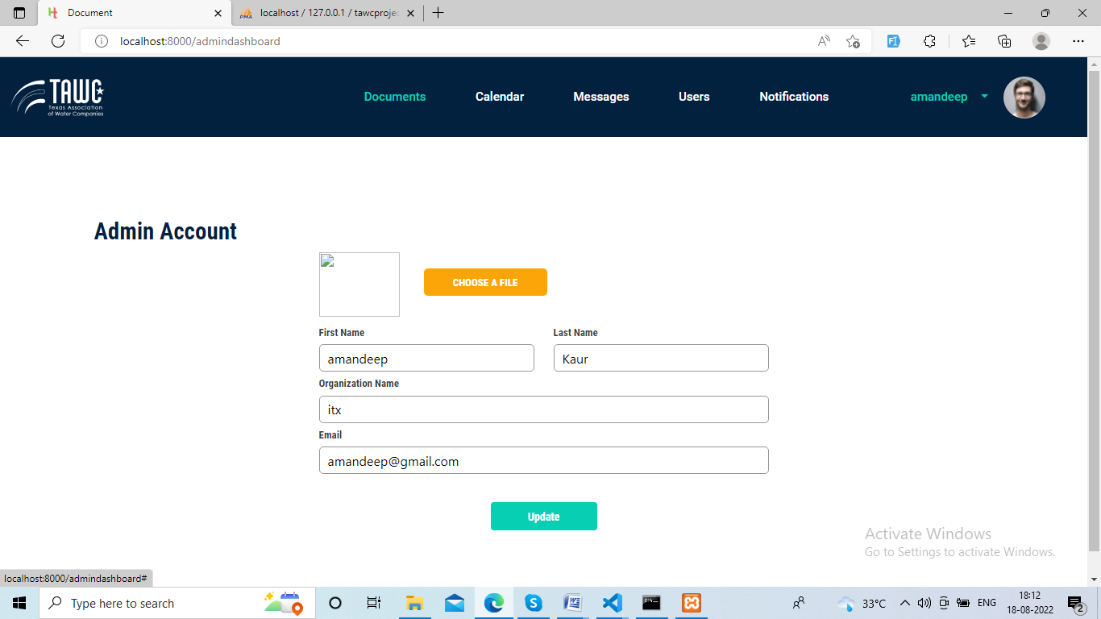

**Count function to count user and admin**

controller

    public function view()

    {

        $admins = User::where('role','admin')->count();

        $users = User::where('role','user')->count();

        return view('superadmin.dashboard', compact('admins', 'users'));

    }

Blade page

<div class="small-box bg-info ">

            <div class="inner">

                <h3>{{$admins}}</h3>

                <p>Admin</p>

            </div>